**＜Query9＞**

**From:** prod_db_tradeserver@ourcompany.com

**Sent:** Monday, January 23, 2026 2:13 PM

**To:** Entity1-MO-FX; Entity2-MO-FX; Entity3-MO-FX; System2-IT

**Subject:** **Edge Condition ALERT** System2 : Exercised Edge Trades

|  |  |  |  |  |  |  |  |
| --- | --- | --- | --- | --- | --- | --- | --- |
| Nomura |  |  |  |  |  |  |  |
|  |  |  |  |  |  |  |  |
| The following trades have just been Exercised with Fixing Rate Matching with Strike/EKI. Please check. |  |  |  |  |  |  |  |
| **TradeId** | **DealId** | **Product Code** | **Book** | **TargetCounterparty** | **Trader** | **SalesPerson** | **IsLastFixingRateMatchesStrike** |
| TS439123456 | 3712341 | TARF | EXSD Entity2 | ABC1-TKY-Entity1 | traderacb | NA | TRUE |
|  |  |  |  |  |  |  |  |
|  |  |  |  |  |  |  |  |
|  |  |  |  |  |  |  |  |

Email generated at 2026-01-23 06:13:02

**<Query10>**

|  |  |
| --- | --- |
| **件名** | **fo approve - RE: **Edge Condition ALERT** System2 : Exercised Edge Trades - 4063091** |
| **差出人** | Entity1-MO-FX |
| **宛先** | Global-TradeingDesk, Entity1-FO-Sales |
| **CC** | Entity1-MO-FX |
| **送信日時** | 2026年1月23日 15:38 |
|  |  |

Hi Traders, Sales

According to the confirmation, DealID: 1234567 should have Exx FX when fixing = Strike, but System2 had not create Exx FX. Please book Exx Ex.

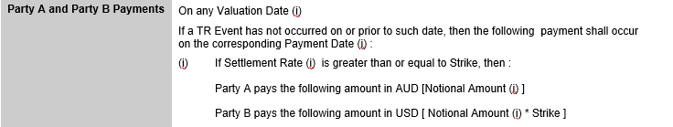

Best regards,

Entity1-MO-FX